**MODULE (Bootstrap Basic & Advanced )-6**

**1)What are the advantages of Bootstrap?**

**Ans.:** Advantages of Bootstrap :

* Easy to use : anybody with just basic knowledge of HTML and CSS can start using Bootstrap.
* Responsive features : Bootsstrap’s responsive CSS edjusts to phone tablets, and desktops
* Consistent design : the design and layouts of your web pages are consistent throughtout your development.
* Save time : using the Bootstrap predefined design templates and classes and concentrate on other development work.
* Browser compatibility : Bootstrap is compatible with all modern browsers

**2) What is a Bootstrap Container, and how does it work?**

**Ans. :**

**Input:**

<!DOCTYPE html>

<html lang="en">

<head>

<title>Bootstrap Example</title>

<meta charset="utf-8">

<meta name="viewport" content="width=device-width, initial-scale=1">

<!-- link -->

<link href="https://cdn.jsdelivr.net/npm/bootstrap@5.2.3/dist/css/bootstrap.min.css" rel="stylesheet">

<script src="https://cdn.jsdelivr.net/npm/bootstrap@5.2.3/dist/js/bootstrap.bundle.min.js"></script>

<link rel="stylesheet" href="bootstrap.css">

</head>

<!-- style -->

<style>

*{

margin: 0;

padding: 0;

box-sizing: border-box;

}

#container1{

margin-top: 40px;

}

#button{

margin-left: 1100px;

margin-top: -50px;

}

</style>

<!-- body start -->

<body>

<nav class="navbar navbar-expand-sm navbar-dark bg-dark">

<!-- container -->

<div class="container-fluid">

<a class="navbar-brand" href="javascript:void(0)">Carousel</a>

<button class="navbar-toggler" type="button" data-bs-toggle="collapse" data-bs-target="#mynavbar">

<span class="navbar-toggler-icon"></span>

</button>

<div class="collapse navbar-collapse" id="mynavbar">

<ul class="navbar-nav me-auto">

<li class="nav-item">

<a class="nav-link " href="javascript:void(0)">Home</a>

</li>

<li class="nav-item">

<a class="nav-link" href="javascript:void(0)">Link</a>

</li>

<li class="nav-item">

<a class="nav-link" href="javascript:void(0)">Disabled</a>

</li>

</ul>

<form class="d-flex">

<input class="form-control me-2" type="text" placeholder="Search">

<button class="btn btn-primary bg-dark border-success" type="button">Search</button>

</form>

</div>

</div>

</nav>

<!-- Carousel -->

<div id="demo" class="carousel slide" data-bs-ride="carousel">

<!-- Indicators/dots -->

<div class="carousel-indicators">

<button type="button" data-bs-target="#demo" data-bs-slide-to="0" class="active"></button>

<button type="button" data-bs-target="#demo" data-bs-slide-to="1"></button>

<button type="button" data-bs-target="#demo" data-bs-slide-to="2"></button>

</div>

<!-- The slideshow/carousel -->

<div class="carousel-inner ">

<div class="carousel-item active bg-secondary text-white text-end p-5"> <h1 >one more for good measure</h1>

<p>Craqs justo odio,dapibus ac facilisis in,egastas eget quam. Donec id elit non mi porta gravida at eget metus <br> nullam id

dolor id nibh ultricies vehicula ut id elit.</p>

<button type="button" class="btn bg-primary text-white">Browse gallery</button>

<div class="carousel-caption " >

</div>

</div>

<div class="carousel-item bg-secondary text-white text-end p-5"><h1>one more for good measure</h1>

<p>Craqs justo odio,dapibus ac facilisis in,egastas eget quam. Donec id elit non mi porta gravida at eget metus <br> nullam id

dolor id nibh ultricies vehicula ut id elit.</p>

<button type="button" class="btn bg-primary text-white">Browse gallery</button>

<div class="carousel-caption">

</div>

</div>

<div class="carousel-item bg-secondary text-white text-end p-5"><h1 >one more for good measure</h1>

<p>Craqs justo odio,dapibus ac facilisis in,egastas eget quam. Donec id elit non mi porta gravida at eget metus <br> nullam id

dolor id nibh ultricies vehicula ut id elit.</p>

<button type="button" class="btn bg-primary text-white">Browse gallery</button>

<div class="carousel-caption">

</div>

</div>

</div>

<!-- Left and right controls/icons -->

<button class="carousel-control-prev" type="button" data-bs-target="#demo" data-bs-slide="prev">

<span class="carousel-control-prev-icon"></span>

</button>

<button class="carousel-control-next" type="button" data-bs-target="#demo" data-bs-slide="next">

<span class="carousel-control-next-icon"></span>

</button>

</div>

<div class="container mt-5 justify-content-around">

<div class="row">

<div class="col-sm-4 text-center">

<img src="" class="rounded-circle bg-secondary" alt="" width="195" height="175">

<h3>Heading</h3>

<p>Donec sed odio dui, etiam porta sem <br> malesuda magna euismod. Nullam id <br>

dolor id nibh ultricies vehicula ut id elit. Morbi <br> leo risus, parta ac consectrtur Ac vestibulum <br> at eros. praesent cornomodo cussus magna.</p>

<button type="button" class="btn bg-secondary text-white">view Details .</button>

</div>

<div class="col-sm-4 text-center">

<img src="" class="rounded-circle bg-secondary" alt="" width="190" height="175">

<h3>Heading</h3>

<p>Donec sed odio dui, etiam porta sem <br> malesuda magna euismod. Nullam id <br>

dolor id nibh ultricies vehicula ut id elit. Morbi <br> leo risus, parta ac consectrtur Ac vestibulum <br> at eros. praesent cornomodo cussus magna.</p>

<button type="button" class="btn bg-secondary text-white">view Details .</button>

</div>

<div class="col-sm-4 text-center">

<img src="" class="rounded-circle bg-secondary" alt="" width="195" height="175">

<h3>Heading</h3>

<p>Donec sed odio dui, etiam porta sem <br> malesuda magna euismod. Nullam id <br>

dolor id nibh ultricies vehicula ut id elit. Morbi <br> leo risus, parta ac consectrtur Ac vestibulum <br> at eros. praesent cornomodo cussus magna.</p>

<button type="button" class="btn bg-secondary text-white">view Details .</button>

</div>

</div>

</div>

<div class="container d-flex justify-content-around" id="container1">

<div> <h1>First featurette heading . it,ll <br>

blow your mind.

</h1>

<p>Donec sed odio dui, etiam porta sem malesuda magna euismod. Nullam id <br>

dolor id nibh ultricies vehicula ut id elit. Morbi leo risus, parta ac consectrtur Ac vestibulum <br> at eros. praesent cornomodo cussus magna.</p>

.</p>

</div>

<div class="bg-info w-25 text-center p-5 " id="box">600*600</div>

</div>

<div class="container d-flex justify-content-around" id="container1">

<div class="bg-info w-25 text-center p-5 " id="box" >600*600</div>

<div class=" " > <h1>Oh yeah, it's that good. See <br>

for yourself

</h1>

<p>Donec sed odio dui, etiam porta sem malesuda magna euismod. Nullam id <br>

dolor id nibh ultricies vehicula ut id elit. Morbi leo risus, parta ac consectrtur Ac vestibulum <br> at eros. praesent cornomodo cussus magna.</p>

.</p>

</div>

</div>

<div class="container d-flex justify-content-around" id="container1">

<div> <h1>And lastly, this one. <br>

Checkmate.

</h1>

<p>Donec sed odio dui, etiam porta sem malesuda magna euismod. Nullam id <br>

dolor id nibh ultricies vehicula ut id elit. Morbi leo risus, parta ac consectrtur Ac vestibulum <br> at eros. praesent cornomodo cussus magna.</p>

.</p>

</div >

<div class="bg-info w-25 text-center pt-5

" id="box">600*600</div>

</div>

<div class="container ">

<p>2017-2018 company inc- privacy-terms</p>

<button type="button" class="btn bg-transpirent text-black " id="button"> Back to top</button>

</div>

<!-- body end -->

</body>

</html>

Output:

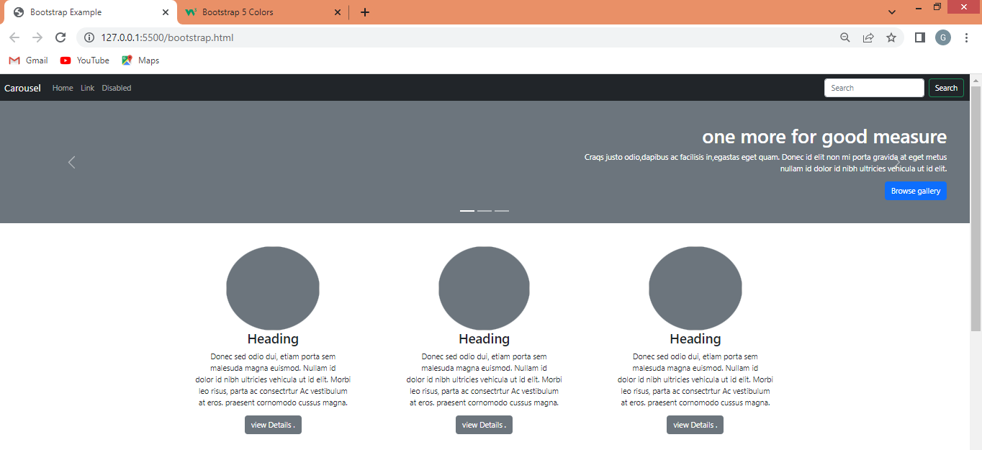

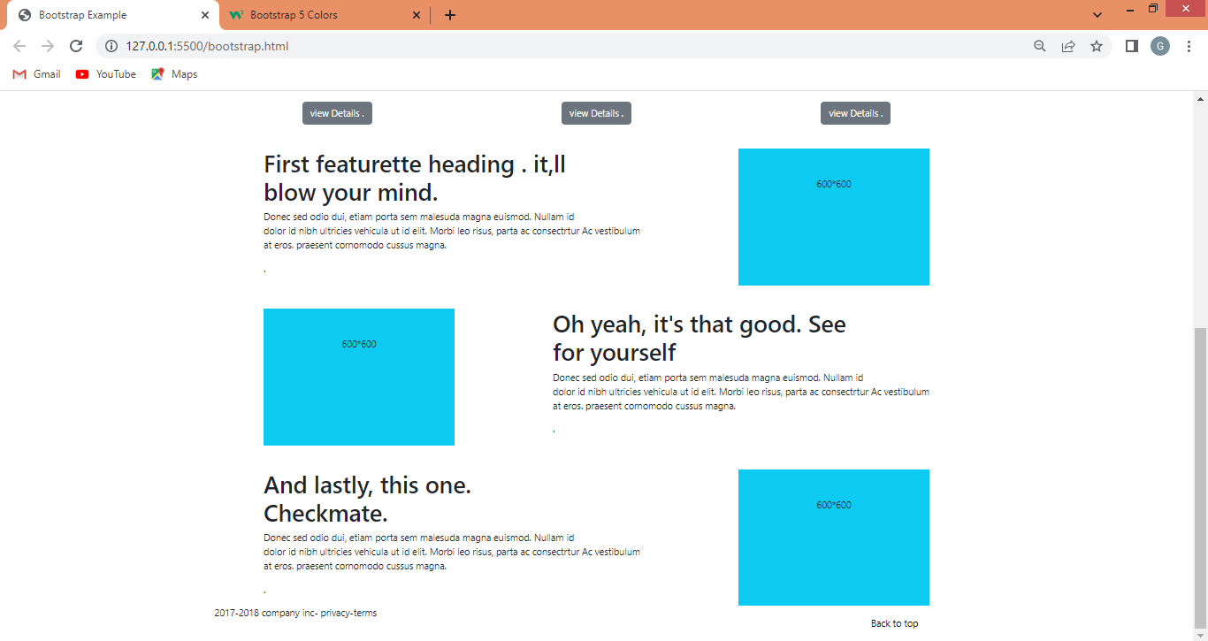

**3) What are the default Bootstrap text settings?**

**Ans.**: By default , the font-size that Bootstrap is of 16px and the line-height 1.5 by default, the font-family is “Helbetica Neue”, Arial ,sans –serif. In addition to thatm all the <p> elements have margin –top of 0 and the margin – bottom is around 1 rem that is 16px by default.

**5) What do you know about the Bootstrap Grid System?**

**Ans.:** Bootstrap’s grid system is built with flexbox and allows up to 12 columns across the page. If you do not want to use all 12 columns individually, you can group the columns together to create wider columns.

The grid system is responsive, and the columns will re-arrannge automatically depending on screen size.

* **Example.**

<!DOCTYPE html>

<html lang="en">

<head>

<title>Bootstrap Example</title>

<meta charset="utf-8">

<meta name="viewport" content="width=device-width, initial-scale=1">

<!-- bootstrap link -->

<link href="https://cdn.jsdelivr.net/npm/bootstrap@5.2.3/dist/css/bootstrap.min.css" rel="stylesheet">

<script src="https://cdn.jsdelivr.net/npm/bootstrap@5.2.3/dist/js/bootstrap.bundle.min.js"></script>

</head>

<body>

<!-- container-fluid -->

<div class="container-fluid mt-3">

<h1>Basic Grid Structure</h1>

<!-- Control the column width, and how they should appear on different devices -->

<div class="row">

<div class="col-sm-6 bg-primary text-white">box 1</div>

<div class="col-sm-6 bg-dark text-white">box 2</div>

</div>

<br>

<div class="row">

<div class="col-sm-4 bg-primary text-white">box 3</div>

<div class="col-sm-4 bg-dark text-white">box 4</div>

<div class="col-sm-4 bg-primary text-white">box5</div>

</div>

<br>

<!-- Or let Bootstrap automatically handle the layout -->

<div class="row">

<div class="col-sm bg-primary text-white">box 6</div>

<div class="col-sm bg-dark text-white">box 7</div>

<div class="col-sm bg-primary text-white">box 8</div>

<div class="col-sm bg-dark text-white">box 9</div>

</div>

<br>

</div>

</body>

</html>

**Output:**

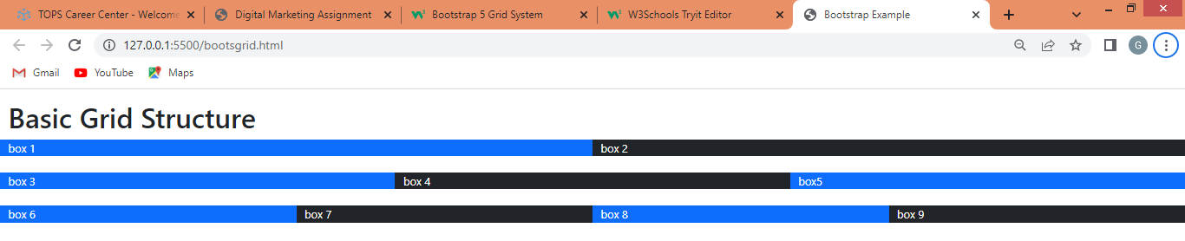

**6) What is the difference between Bootstrap 4 and Bootstrap 5**

**Ans.:**

|  |  |
| --- | --- |
| * **Bootstrap 4** | * **Bootstrap 5** |
| * It has limited colors. | * Extra colors added with the looks, A card improved color palette. There are various shades   Available to choose. |
| * It has jquery and all related pluguns. | * Jquery is removed and switched to vanilla JS with some working plugins. |
| * Bootstrap 4 doesn’t have its own SVG icons, we have to use font awesome for icons. | * Bootstrap 5 have its   own SVG icon. |
| * Navbar – we have inline-block property and we will get white dropdown as default for dropdown-menu dark class. | * Inline block property is removed and we will get black dropdown as default for dropdown-menu-dark class. |
| * It does not support offcanvas component. | * It support offcanvas component. |

**7) What is a Button Group, and what is the class for a basic Button Group?**

**Ans.:**

Bootstrap allows you to group a series of buttons together (on a single line ) a button group.

Use a <div> element with class .btn-group to create a button group.

<div class="btn-group">

<button type="button" class="btn btn-primary">button1</button>

<button type="button" class="btn btn-primary"> button2</button>

<button type="button" class="btn btn-primary">button3 </button>

</div>

**8) How can you use Bootstrap to make thumbnails?**

**Ans.:**

* **Input:**

<!DOCTYPE html>

<html lang="en">

<head>

<title>Thumbnail images</title>

<!-- link -->

<link rel="stylesheet"href="http://maxcdn.bootstrapcdn.com/bootstrap/3.3.6/css/bootstrap.min.css"/>

<script src="https://ajax.googleapis.com/ajax/libs/jquery/1.12.0/jquery.min.js"></script>

<script src="http://maxcdn.bootstrapcdn.com/bootstrap/3.3.6/js/bootstrap.min.js"></script>

</head>

<body>

<!-- body start -->

<h3 style="color: green">Bootstrap thumbnails</h3>

<div class="row">

<div class="col-sm-6 col-md-3">

<a href="#" class="thumbnail">

<img src="https://encrypted-tbn0.gstatic.com/images?q=tbn:ANd9GcQOVfzdfHT6A9m6r-cFVS2DmNcVwRdX2AHOmw&usqp=CAU"

style="height: 200px; width: 400px"/>

</a>

</div>

<div class="col-sm-6 col-md-3">

<a href="#" class="thumbnail">

<img src=

"https://encrypted-tbn0.gstatic.com/images?q=tbn:ANd9GcRF6vaOI9e1w_mFCl0YdajZa_QgqBu7P9zMKg&usqp=CAU"

style="height: 200px; width: 400px"/>

</a>

</div>

<div class="col-sm-6 col-md-3">

<a href="#" class="thumbnail">

<img src=

"https://encrypted-tbn0.gstatic.com/images?q=tbn:ANd9GcRifLydIs6ozs-A01wMvZLpALa0gx97bBjcZg&usqp=CAU"

style="height: 200px; width: 400px"/>

</a>

</div>

<div class="col-sm-6 col-md-3">

<a href="#" class="thumbnail">

<img src=

"https://encrypted-tbn0.gstatic.com/images?q=tbn:ANd9GcQC4lZHz-glV0qjO45pLWgKAYFuMPw-LbFo_A&usqp=CAU"

style="height: 200px; width: 400px"/>

</a>

</div>

</div>

<!-- body end -->

</body>

</html>

* **Output:**

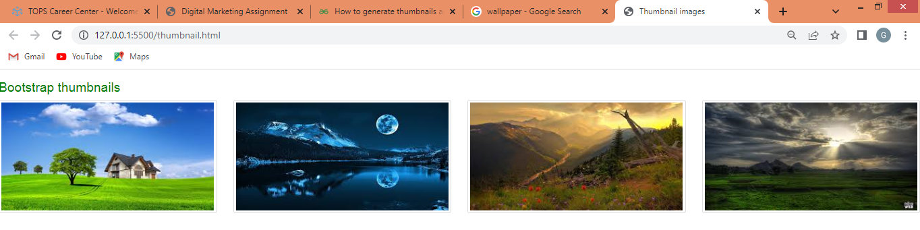

**9) In Bootstrap 4, what is flexbox?**

**Ans.**

**Input:**

<!DOCTYPE html>

<html lang="en">

<head>

<title>Bootstrap Example</title>

<meta charset="utf-8">

<meta name="viewport" content="width=device-width, initial-scale=1">

<!-- link -->

<link rel="stylesheet" href="https://cdn.jsdelivr.net/npm/bootstrap@4.6.2/dist/css/bootstrap.min.css">

<script src="https://cdn.jsdelivr.net/npm/jquery@3.6.4/dist/jquery.slim.min.js"></script>

<script src="https://cdn.jsdelivr.net/npm/popper.js@1.16.1/dist/umd/popper.min.js"></script>

<script src="https://cdn.jsdelivr.net/npm/bootstrap@4.6.2/dist/js/bootstrap.bundle.min.js"></script>

</head>

<body>

<!-- body start -->

<div class="container mt-3">

<h2>Flex</h2>

<p>To create a flexbox container and transform direct children into flex items, use the d-flex class:</p>

<div class="d-flex p-3 bg-secondary text-white">

<div class="p-2 bg-info">Flex item 1</div>

<div class="p-2 bg-warning">Flex item 2</div>

<div class="p-2 bg-primary">Flex item 3</div>

</div>

</div>

<!-- body end -->

</body>

</html>

**Output:**

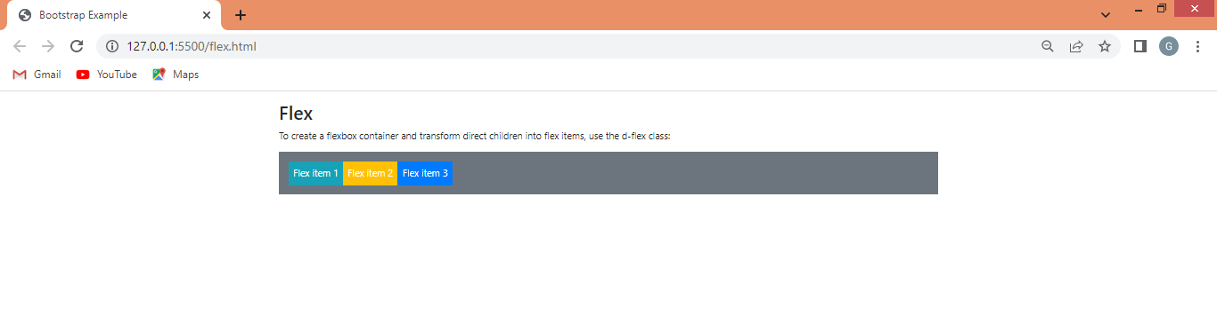

**10) How can one create an alert in Bootstrap?**

**Ans.:**

* Bootstrap Alerts are used to provide an easy way to create predefined alert messages. Alert adds a style to your messages to make it more appealing to the users.

Alerts are created with the .alert class, followed by one of the four contextual classes .alert-success, .alert-info, .alert-warning or .alert-danger

**Input:**

<!DOCTYPE html>

<html lang="en">

<head>

<title>Bootstrap Example</title>

<meta charset="utf-8">

<meta name="viewport" content="width=device-width, initial-scale=1">

<!-- link -->

<link rel="stylesheet" href="https://maxcdn.bootstrapcdn.com/bootstrap/3.4.1/css/bootstrap.min.css">

<script src="https://ajax.googleapis.com/ajax/libs/jquery/3.6.4/jquery.min.js"></script>

<script src="https://maxcdn.bootstrapcdn.com/bootstrap/3.4.1/js/bootstrap.min.js"></script>

</head>

<body>

<!-- body start -->

<div class="container">

<h2>Alert Links</h2>

<p>Add the alert-link class to any links inside the alert box to create "matching colored links".</p>

<div class="alert alert-success">

<strong>Success!</strong> You should <a href="#" class="alert-link">read this message</a>.

</div>

<div class="alert alert-info">

<strong>Info!</strong> You should <a href="#" class="alert-link">read this message</a>.

</div>

<div class="alert alert-warning">

<strong>Warning!</strong> You should <a href="#" class="alert-link">read this message</a>.

</div>

<div class="alert alert-danger">

<strong>Danger!</strong> You should <a href="#" class="alert-link">read this message</a>.

</div>

</div>

<!-- body end -->

</body>

</html>

**Output:**

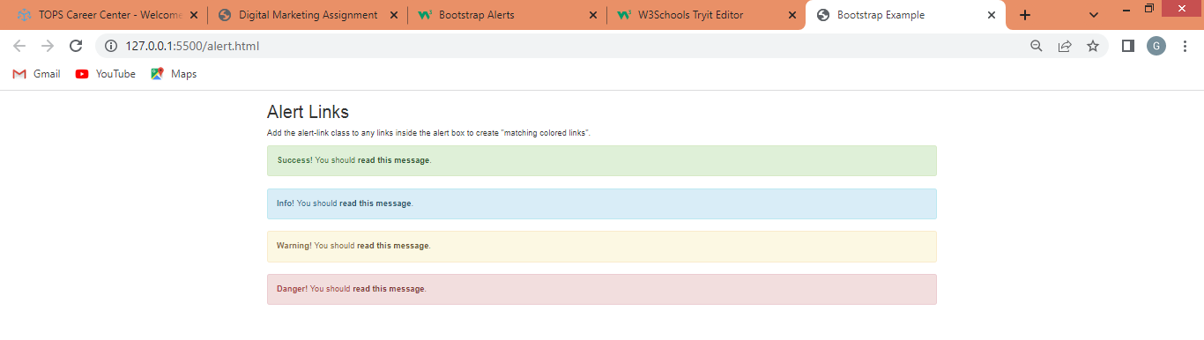

**11) What is a bootstrap card and how would you create one?**

**Ans.:** A card in Bootstrap 4 is a bordered box with some padding around its content. It includes options for headers, footers, content, colors, etc.

**Input:**

<!DOCTYPE html>

<html lang="en">

<head>

<title>Bootstrap Example</title>

<meta charset="utf-8">

<meta name="viewport" content="width=device-width, initial-scale=1">

<!-- link -->

<link rel="stylesheet" href="https://cdn.jsdelivr.net/npm/bootstrap@4.6.2/dist/css/bootstrap.min.css">

<script src="https://cdn.jsdelivr.net/npm/jquery@3.6.4/dist/jquery.slim.min.js"></script>

<script src="https://cdn.jsdelivr.net/npm/popper.js@1.16.1/dist/umd/popper.min.js"></script>

<script src="https://cdn.jsdelivr.net/npm/bootstrap@4.6.2/dist/js/bootstrap.bundle.min.js"></script>

</head>

<body>

<!-- body start -->

<div class="container">

<h2> Card</h2>

<p></p>

<div class="card" style="width:400px">

<img class="card-img-top" src="card image.jpg" alt="Card image" style="width:100%">

<div class="card-body">

<h4 class="card-title">Richard Taylor</h4>

<p class="card-text">some example</p>

<a href="#" class="btn btn-primary stretched-link">See Profile</a>

</div>

</div>

</div>

<!-- body end -->

</body>

</html>

**Output:**

